Project By : Hamza Ishaq

Roll Number : 33090

Email Address : Ishaqhamza212@gmail.com

Number : 03343149433

Unit Converter :

This project is a Python program that allows the user to convert between different units of length, mass, temperature, and time. The program uses a simple text-based interface that displays a menu of options and prompts the user to enter their choice. The program then asks the user to enter the value and the unit they want to convert from and to, and displays the result. The program also handles invalid inputs and allows the user to exit at any time.

Code Logic and Design :

The code logic and design of the program are as follows:

* The program starts by printing a welcome message and a mode selection menu that shows four options: length, mass, temperature, and time.
* The program uses a while loop to keep asking the user to enter their mode from 1 to 4 until they enter a valid input or choose to exit.
* The program then enters a different while loop depending on the mode selected by the user. Each loop prints a conversion unit menu that shows the possible conversions for that mode and prompts the user to enter their choice from 1 to 21 ( based on unit).
* The program then asks the user to enter the value and the unit they want to convert from and to, and performs the appropriate calculation using the formulas for each conversion. The program prints the result and repeats the loop .
* The program also checks for invalid inputs such as non-numeric values, out-of-range choices, or incompatible units, and prints an error message if any of these occur. The program then returns to the previous menu and prompts the user again.
* The program uses if statements to determine the mode and the conversion chosen by the user, and to perform the corresponding calculation.
* The program does not use any functions or classes, but only basic Python features such as variables, operators, input/output, and control structures.

Screenshots with Explanations

Here are some screenshots of the program in action with explanations:

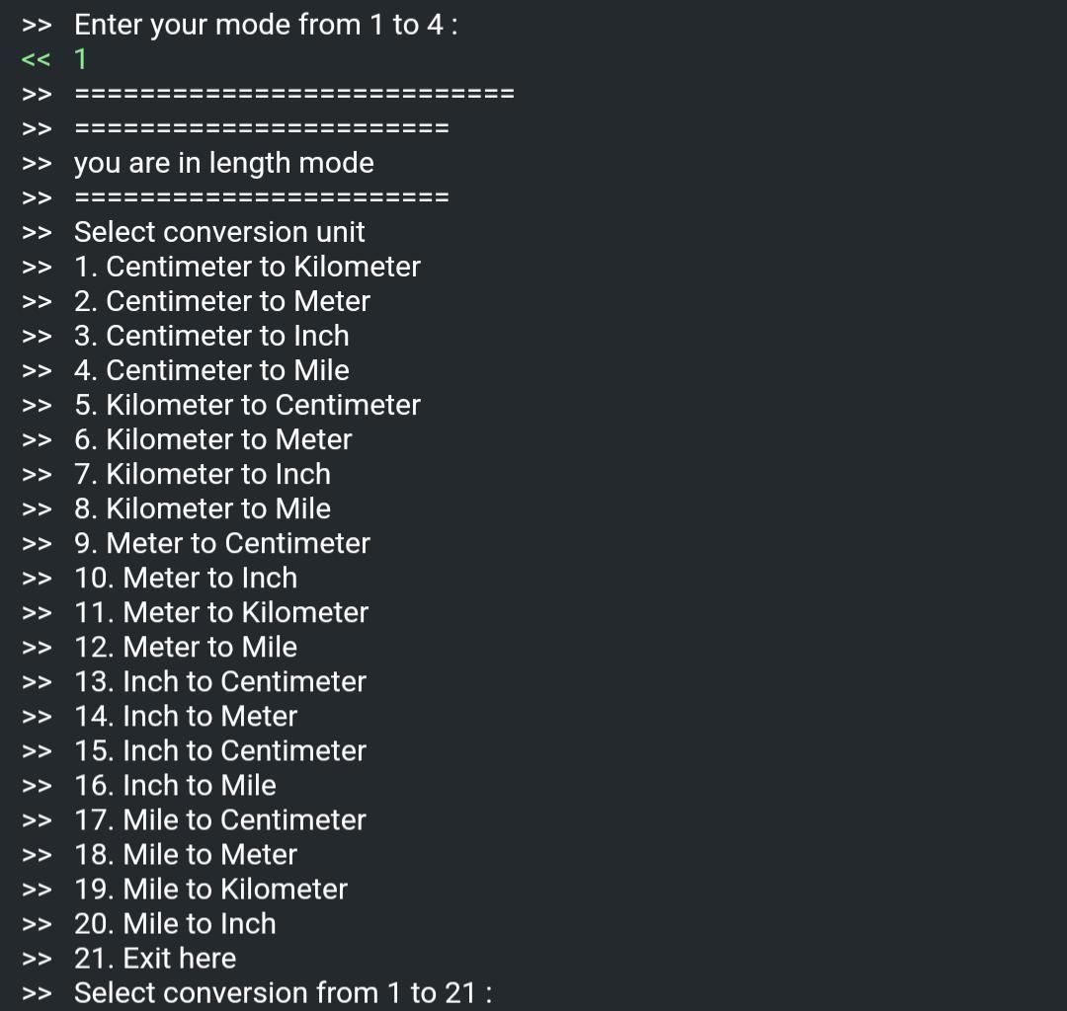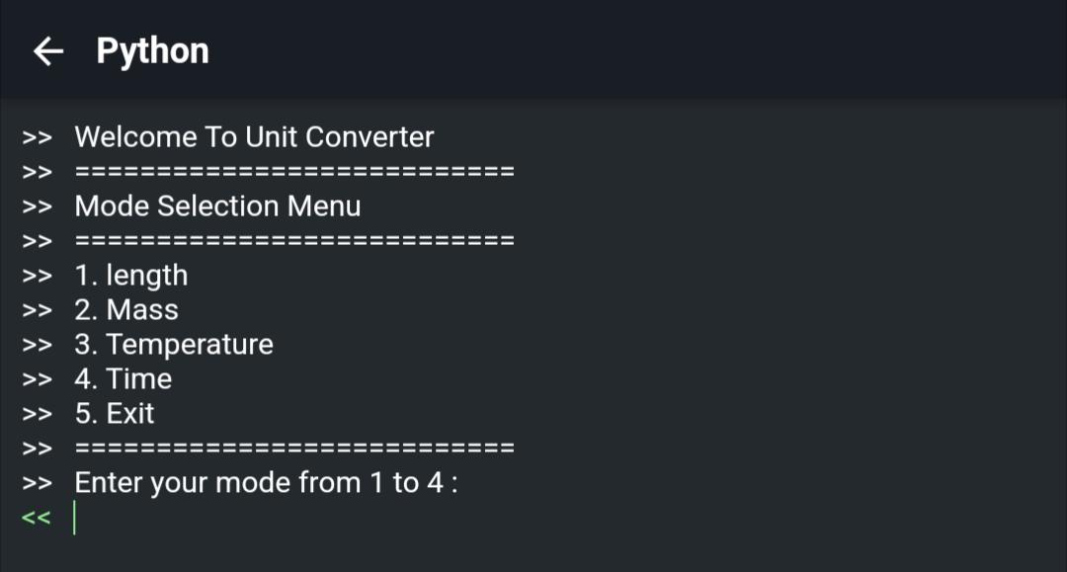

These screenshots shows the welcome message and the mode selection menu. The user enters 1 to choose the length mode.

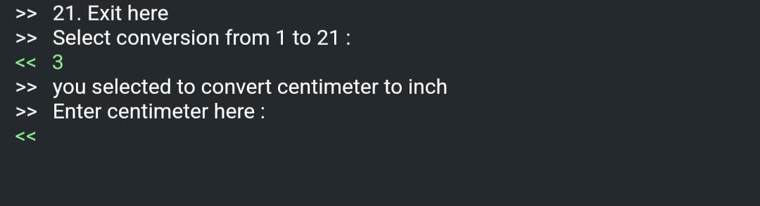

This screenshot shows the conversion unit menu for the length mode. The user enters 3 to choose the centimeter to inch conversion.



This screenshot shows the prompt for the value and the unit to convert from and to. The user enters 50 and cm.

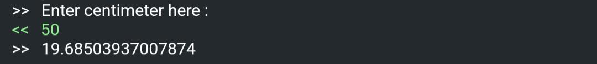

This screenshot shows the result of the conversion. The program prints that 50 cm is equal to 19.68503937007874 inches.





This screenshot shows the conversion unit menu for the length mode again. The user enters 21 to exit the length mode.

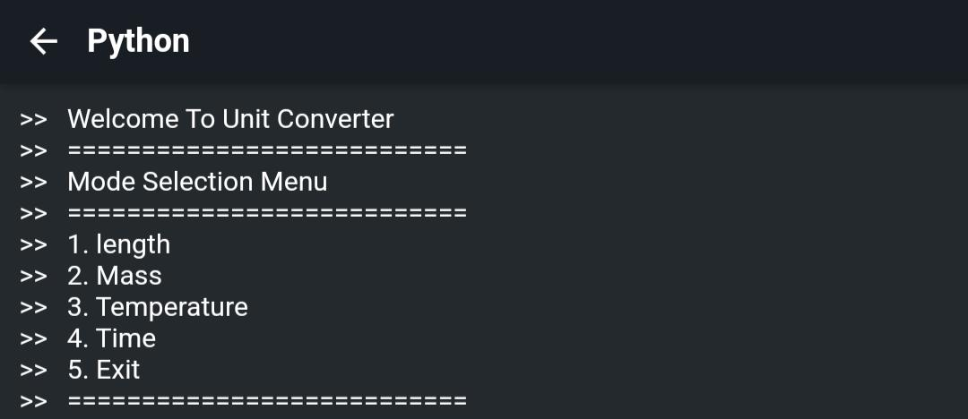



This screenshot shows the mode selection menu again. The user enters 5 to exit the program.

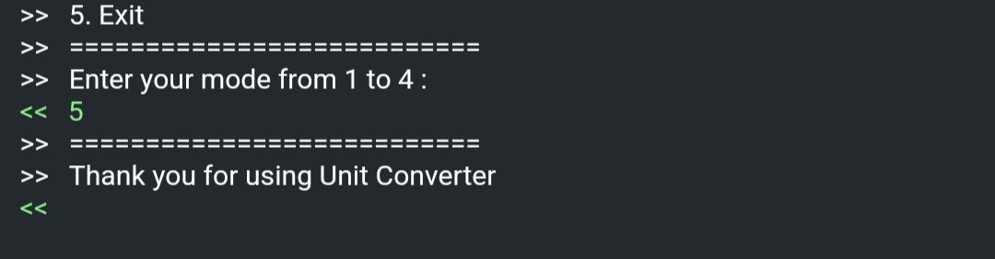

This screenshot shows the goodbye message and the program terminates.

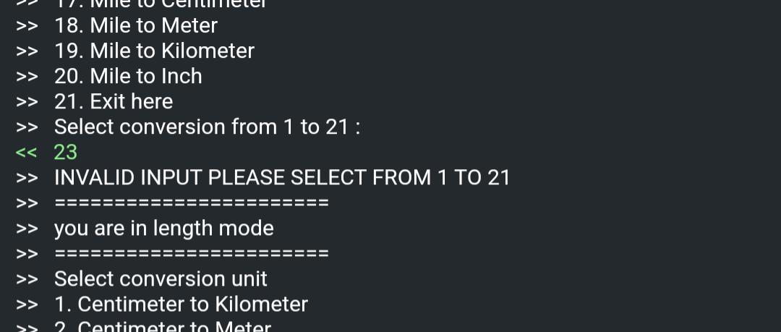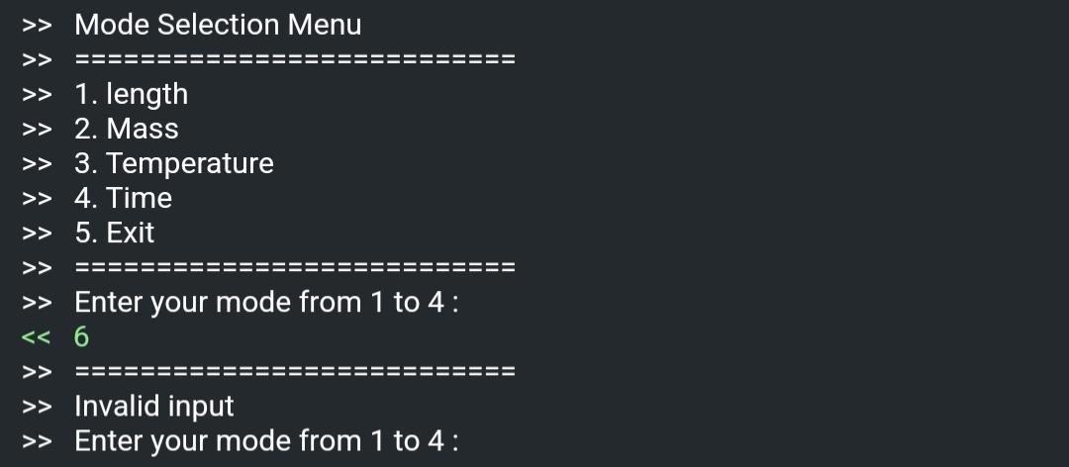

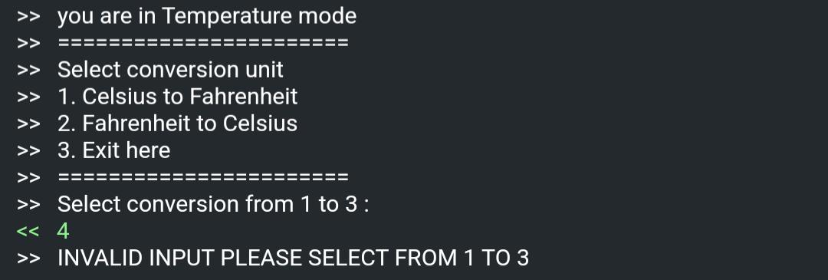

These Screenshots Shows Error on wrong input

Link to GitHub Repository

You can find the source code and the documentation for this project on GitHub at [https://github.com/Hamzaisadev/UNIT-CONVERTER-/edit/main/Unit%20Converter.py].

Additional Information

Some additional information about this project are:

The program uses the following conversion formulas:

Centimeter to kilometer: divide the length value by 100000

Centimeter to meter: divide the length value by 100

Centimeter to inch: divide the length value by 2.54

Centimeter to mile: for an approximate result, divide the length value by 160900

Kilometer to centimeter: multiply the length value by 100000

Kilometer to meter: multiply the length value by 1000

Kilometer to inch: multiply the length value by 39370.0787

Kilometer to mile: multiply the length value by 0.621371

Meter to centimeter: multiply the length value by 100

Meter to inch: multiply the length value by 39.3700787

Meter to kilometer: divide the length value by 1000

Meter to mile: divide the length value by 1609.344

Inch to centimeter: multiply the length value by 2.54

Inch to meter: divide the length value by 39.3700787

Inch to kilometer: divide the length value by 39370.0787

Inch to mile: divide the length value by 63360

Mile to centimeter: multiply the length value by 160900

Mile to meter: multiply the length value by 1609.344

Mile to kilometer: multiply the length value by 1.609344

Mile to inch: multiply the length value by 63360

The program uses the same logic and formulas for the other modes, but with different units and values. For example, for the mass mode, the units are gram, kilogram, ounce, and pound, and the formulas are:

Gram to kilogram: divide the mass value by 1000

Gram to ounce: divide the mass value by 28.3495

Gram to pound: divide the mass value by 453.592

Kilogram to gram: multiply the mass value by 1000

Kilogram to ounce: multiply the mass value by 35.274

Kilogram to pound: multiply the mass value by 2.20462

Ounce to gram: multiply the mass value by 28.3495

Ounce to kilogram: divide the mass value by 35.274

Ounce to pound: divide the mass value by 16

Pound to gram: multiply the mass value by 453.592

Pound to kilogram: divide the mass value by 2.20462

Pound to ounce: multiply the mass value by 16

For the temperature mode, the units are Celsius, Fahrenheit, and Kelvin, and the formulas are:

Celsius to Fahrenheit: multiply the temperature value by 1.8 and add 32

Celsius to Kelvin: add 273.15 to the temperature value

Fahrenheit to Celsius: subtract 32 from the temperature value and divide by 1.8

Fahrenheit to Kelvin: subtract 32 from the temperature value, divide by 1.8, and add 273.15

Kelvin to Celsius: subtract 273.15 from the temperature value

Kelvin to Fahrenheit: subtract 273.15 from the temperature value, multiply by 1.8, and add 32

For the time mode, the units are second, minute, hour, and day, and the formulas are:

Second to minute: divide the time value by 60

Second to hour: divide the time value by 3600

Second to day: divide the time value by 86400

Minute to second: multiply the time value by 60

Minute to hour: divide the time value by 60

Minute to day: divide the time value by 1440

Hour to second: multiply the time value by 3600

Hour to minute: multiply the time value by 60

Hour to day: divide the time value by 24

Day to second: multiply the time value by 86400

Day to minute: multiply the time value by 1440

Day to hour: multiply the time value by 24

The program does not handle negative values or fractions, and assumes that the user enters only positive integers.

The program does not handle units that are not listed in the menus, and assumes that the user enters only valid units.

The program does not handle conversions that are not possible or meaningful, such as temperature to length or time to mass.

I hope this overview helps you understand the project better. If you have any questions or feedback, please let me know.

Can I expect full number ?💁